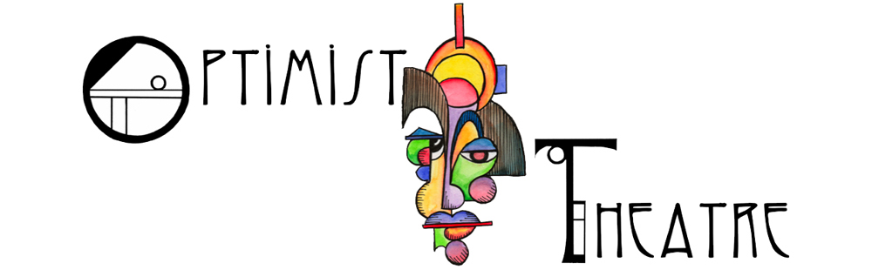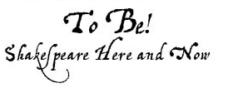

www.OptimistTheatre.org/ToBe

Delete and Type Your Text Here

Join us for a dynamic, first-person experience with the most beloved playwright in the English Language. Meet William Shakespeare himself in ...